1. **Write a Python Program to Find the Factorial of a Number?**

**Ans:**

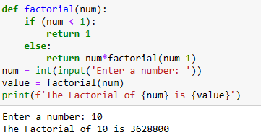

1. **Write a Python Program to Display the multiplication Table?**

**Ans:**

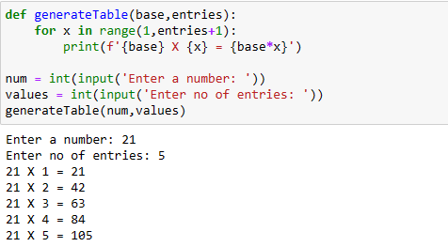

1. Write **a Python Program to Print the Fibonacci sequence?**

**Ans:**

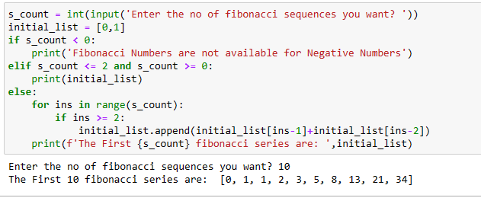

1. **Write a Python Program to Check Armstrong Number?**

**ans:**

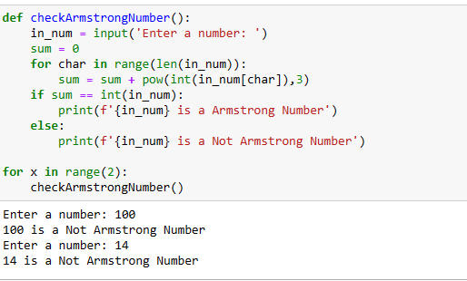

1. **Write a Python Program to Find Armstrong Number in an Interval?**

**Ans:**

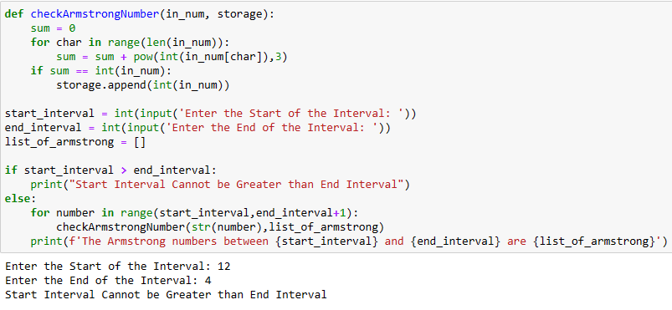

1. **Write a Python Program to Find the Sum of Natural Numbers?**

**ans:**

